Assignment - 11
Task - 1
Description: Stack class implementation
Task: Ask AI to implement a stack class with push(), pop(), peek() and is_empty() methods
Prompt: Write a Python program that takes user input to operate a Stack class. Implement methods: push(), pop(), peek(), and is_empty(). Let the user enter values to push and choose operations

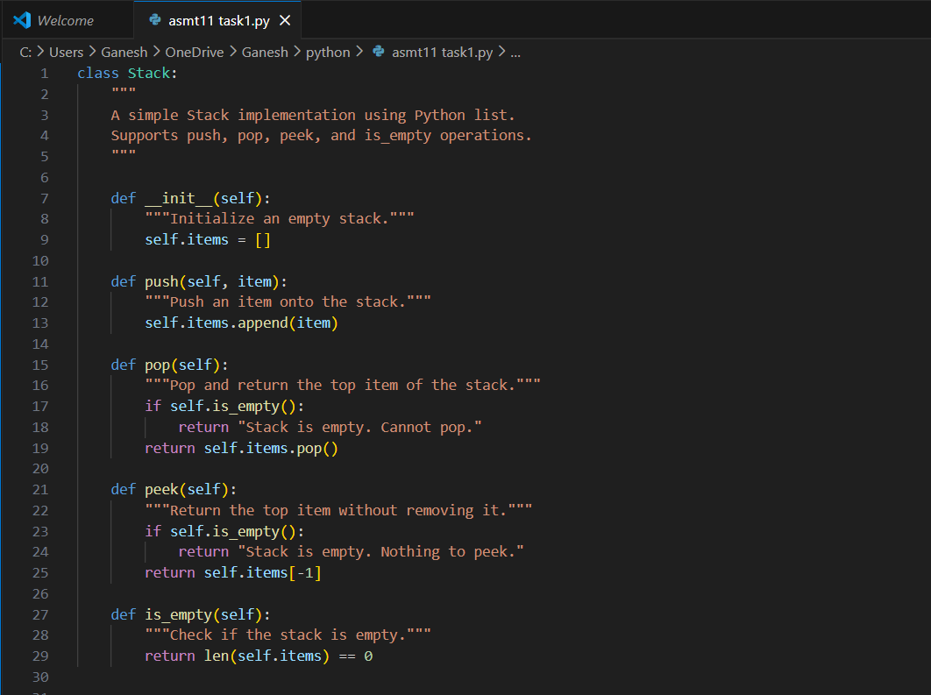
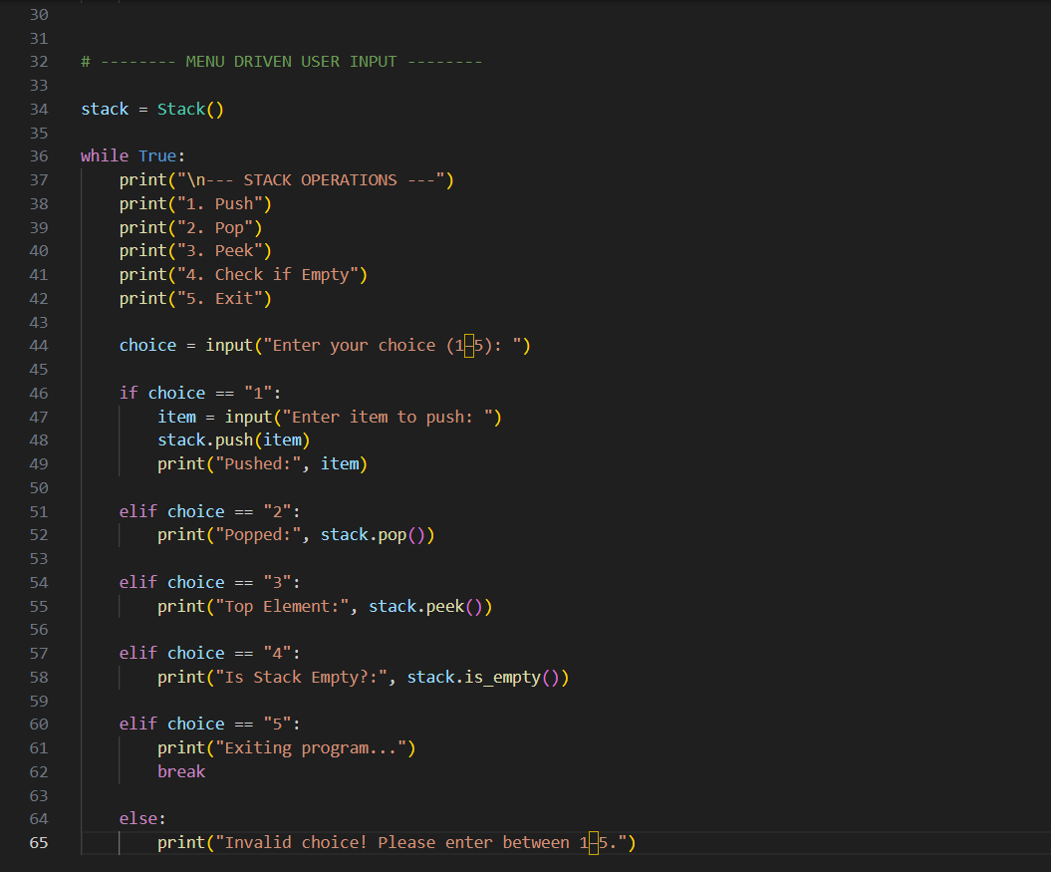

Practical Output:

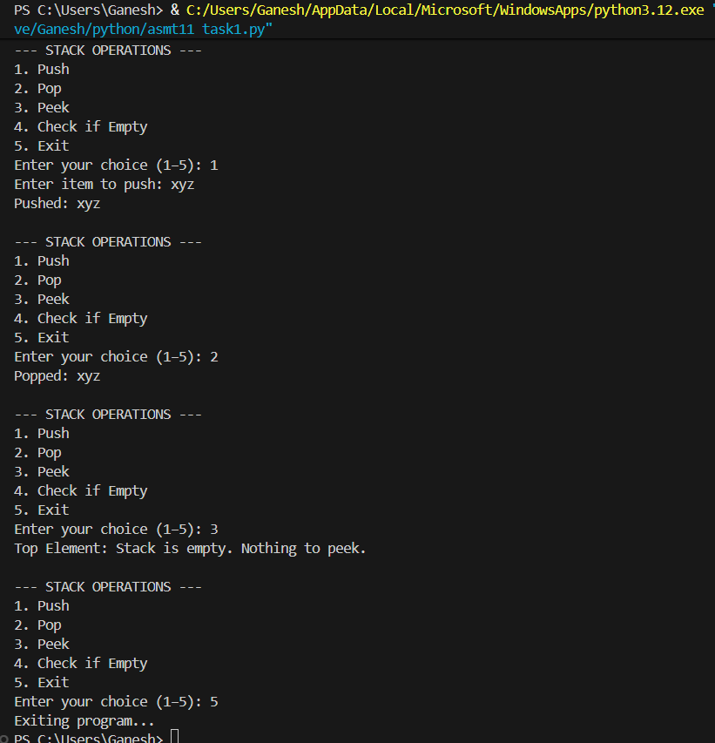

Task - 2
Description: Queue Implementation
Task: Use AI to generate a Queue class with enqueue(), dequeue(), and is_empty().
Prompt: Write a Python program that takes user input to create a Queue class with enqueue(), dequeue(), and is_empty() methods. Then let the user add and remove items from the queue.
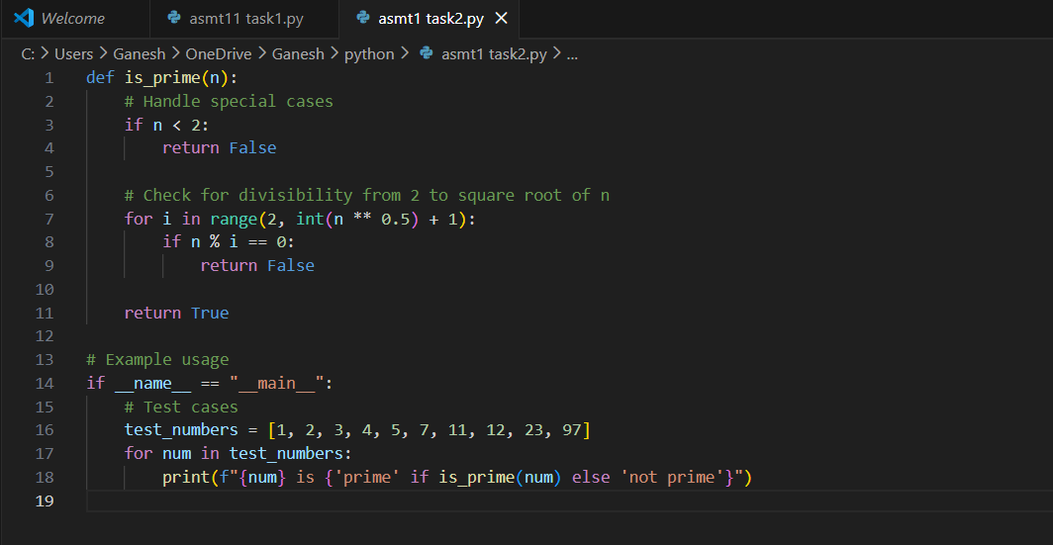

Practical Output:

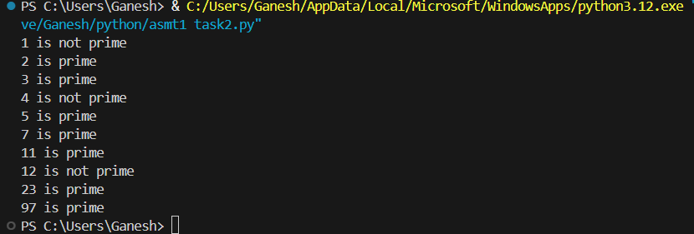

Task - 3
Description: Linked List Implementation
Task: Ask AI to create a singly linked list with insert_at_end(), insert_at_beginning(), and display().
Prompt: Create a Python program for a singly linked list with insert_at_beginning(), insert_at_end(), and display() methods. Take user input to insert and view the list.
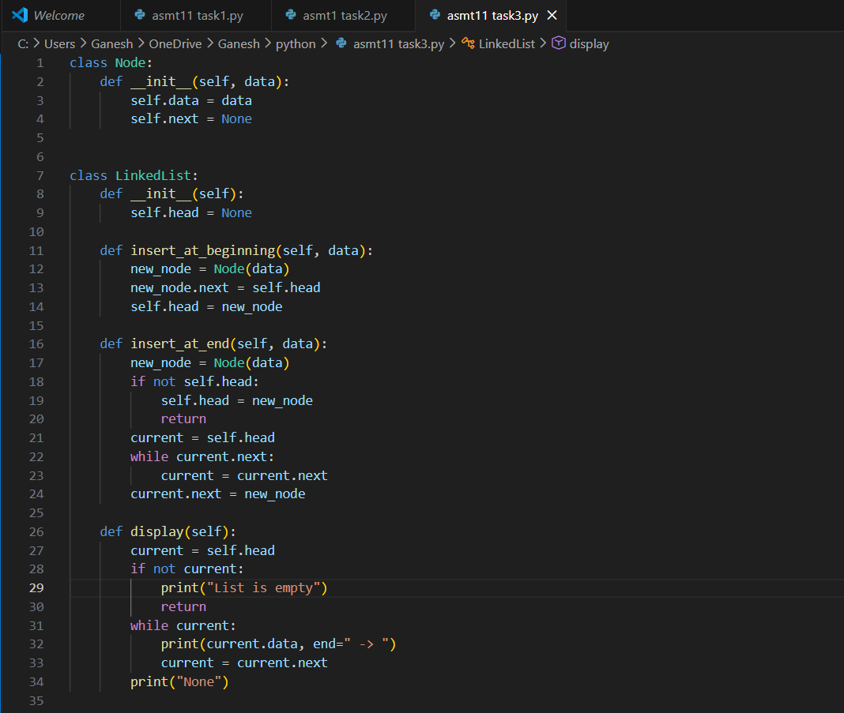
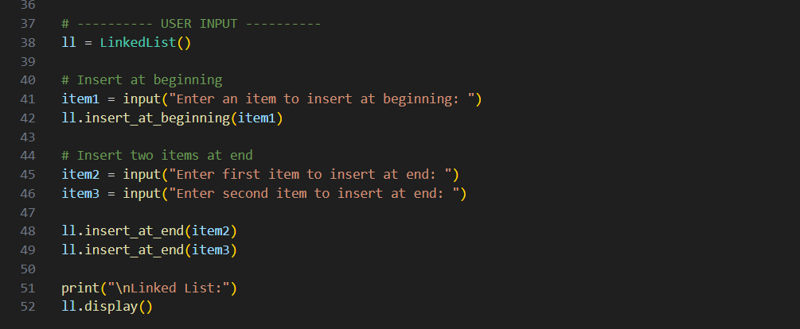

Practical Output:

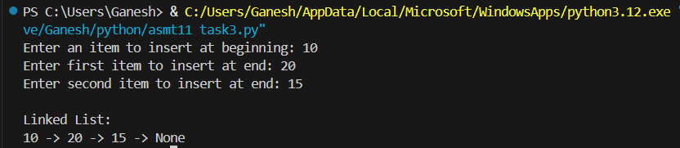

Task - 4
Description: Binary Search Tree (BST)
Task: Ask AI to generate a simple BST with insert() and inorder_traversal(). Prompt: Write a Python program to implement a Binary Search Tree with insert() and inorder_traversal(), and allow user input to add nodes.

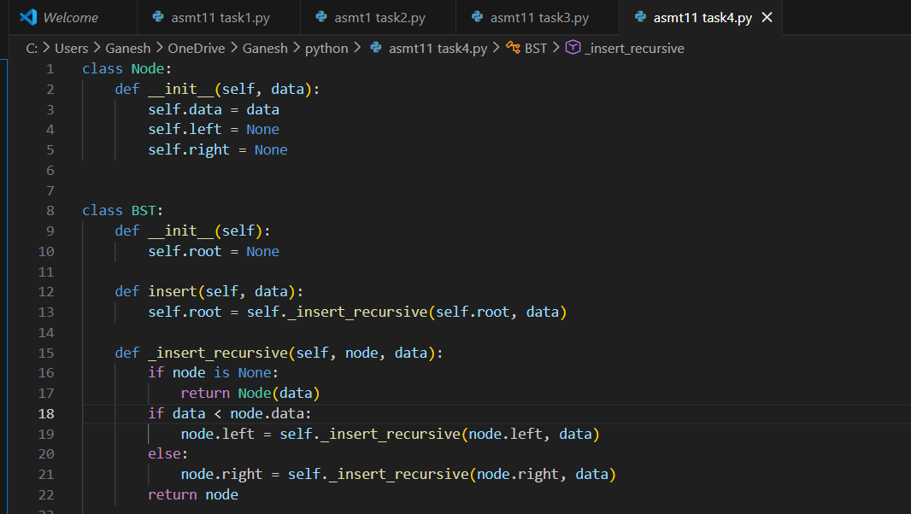
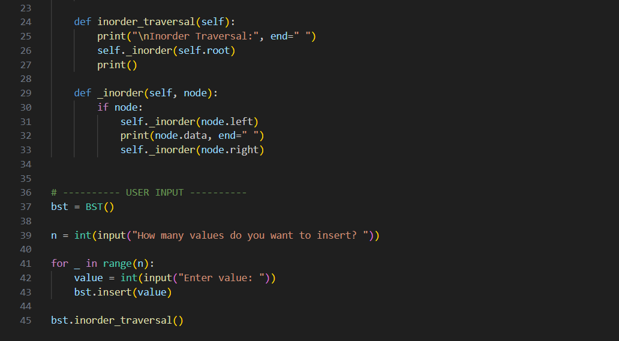

Practical Output:

